**HDFS**

1. Create a (Yourname).txt file in Cent OS  
   2. Write some information in that particular file.  
   3. Create a directory of your name in Hadoop File System.

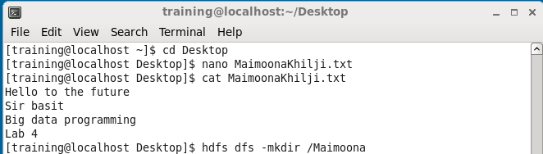

4. Copy (Yourname).txt file from your Cent OS to Hadoop Environment.  
5. List the directory.

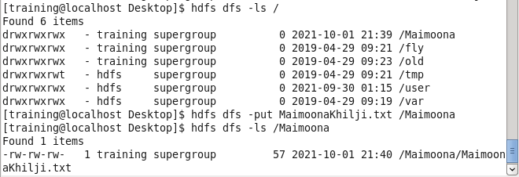

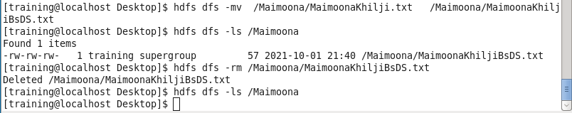  
6. Rename (Yourname).txt file to (Yourname+BSDS).txt  
7. List the directory Attach Screenshot in Word Document.  
8. Write command to remove that (Yourname+BSDS).txt file.

**Hive**

SELECT * FROM games;  
  
SELECT name,year,inventor FROM games;  
  
SELECT name, list_price+5 FROM games;  
  
SELECT name, round(list_price) FROM games;  
  
SELECT name, -list_price FROM games;  
  
SELECT 5/2;  
  
SELECT concat(name, ' is for players age ',min_age,' or older') FROM games;  
  
SELECT year+10 FROM games;  
  
SELECT DISTINCT min_age FROM games;  
  
SELECT distinct concat(substring(year,1,3),"0s") from games;  
  
SELECT * from games where list_price<10;  
  
SELECT name from games where inventor='Elizabeth Magie';  
  
SELECT * from wax.crayons where red+green+blue >650;  
  
SELECT color,red+green+blue as RGB from wax.crayons where red+green+blue >650;  
  
SELECT * from games where max_players>=6 and list_price<=10;  
  
SELECT * from games where NOT name="Risk";  
  
SELECT * from games where name!="Risk";  
  
SELECT * from games where NOT name = "Candy Land" and name="Risk";  
  
SELECT * from games where NOT name = "Candy Land" OR name="Risk";  
  
SELECT * from games where NOT name = "Candy Land" and NOT name="Risk";  
  
SELECT * from games where NOT (name = "Candy Land" OR name="Risk");  
  
SELECT * from games where name!= "Candy Land" and name!="Risk";  
  
SELECT count(*) as num_rows from default.employees;  
  
SELECT sum(salary) as total_salary from default.employees;  
  
SELECT office_id,count(*) from employees where salary>35000 GROUP BY office_id;  
  
  
SELECT min_age,max_players,count(*) from fun.games GROUP BY min_age,max_players;  
  
SELECT min_age from fun.games GROUP BY min_age;  
  
SELECT distinct min_age from fun.games;  
  
SELECT (list_price*1.25) FROM fun.games;  
  
SELECT round(price*1.25,0) from fun.inventory;--21% tax  
  
  
SELECT concat(list_price,"s") FROM fun.games;  
  
SELECT shop,sum( qty*price) from fun.inventory GROUP BY shop;  
  
SELECT shop,sum( qty*price) from fun.inventory GROUP BY shop having sum(qty*price)>300;  
  
select shop, sum(qty)from fun.inventory WHERE price is NOT NULL group by shop ORDER BY shop;  
  
--quiz  
  
Select round(avg(dep_delay)) as average_oF_dep_delay from flights where sched_dep_time>1300;  
  
  
Select round(avg(air_time)/60) as avg_air from fly.flights;  
  
  
select manufacturer,count(*) from planes group by manufacturer having count(*)=1;  
  
  
SELECT origin, avg(dep_delay) from flights group BY origin having avg(dep_delay) > 30;  
  
  
Select * from flights where carier =”AA” order by distance DESC, air_time asc;  
  
select * FROM toys join makers m on [m.id](http://m.id/) =toys.maker_id;  
  
SELECT * FROM employees FULL OUTER JOIN offices on employees.office_id=offices.office_id;  
  
SELECT employees.office_id ,count(employees.empl_id) as num FROM employees  
FULL OUTER JOIN offices on employees.office_id=offices.office_id  
group BY employees.office_id;  
  
SELECT offices.city ,count(employees.empl_id) as num_employees FROM employees  
FULL OUTER JOIN offices on employees.office_id=offices.office_id  
group BY offices.city;  
  
SELECT offices.city ,count(employees.empl_id) as num_employees FROM employees  
RIGHT JOIN offices on employees.office_id=offices.office_id  
group BY offices.city;  
  
  
SELECT offices.city ,count(employees.empl_id) as num_employees FROM employees  
RIGHT JOIN offices on employees.office_id=offices.office_id  
group BY offices.city;

SELECT f.carrier,name,origin, dest,type,manufacturer,model,p.year,engines, seats,engine

From flights f Join airlines a ON (f.carrier =a.carrier)

join planes p on (f.tailnum = p.tailnum)

where origin ='BOS' OR dest='BOS';

CREATE view craft_information As

SELECT f.carrier,name,origin, dest,type,manufacturer,model,p.year,engines, seats,engine

From flights f Join airlines a ON (f.carrier =a.carrier)

join planes p on (f.tailnum = p.tailnum);

SELECT * from craft_information where origin ='BOS' OR dest='BOS';

show TABLES;

DESCRIBE craft_information;

DESCRIBE FORMATTED craft_information;

ALTER VIEW craft_information RENAME TO craft_info;

SHOW TABLES;

ALTER VIEW craft_info as SELECT DISTINCT carrier FROM flights;

SELECT * from craft_info;

DESCRIBE craft_info;

drop view craft_info;